EAST ANGLIAN ORIENTEERING ASSOCIATION
EAST ANGLIAN SCHOOLS ORIENTEERING CHAMPIONSHIPS 2015

HYLANDS PARK, CHELMSFORD
SUNDAY 17th MAY

The 2015 East Anglian Schools Championships will take place on Sunday 17th May at Hylands Park. Further details will be posted nearer the time.

Pupils at any school or youth group within the catchment areas of constituent Clubs of the East Anglian Orienteering Association are eligible to enter.

Children compete in their academic year group and younger pupils up to Year 8 may compete as pairs.

There is no restriction on the number of competitors which may be entered. They will navigate around the park using a detailed map.

Full rules can be found here
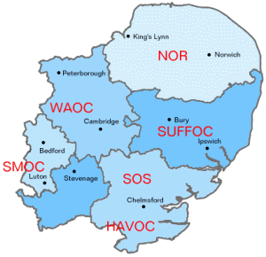

http://www.eaoa.org.uk/EASchools2014Rules.pdf

Awards will be made to the three fastest girls and boys in each school year and the first place team in each of the following categories, Primary Girls & Boys; Year 7 & 8 Girls & Boys; Year 9 &10 Girls & Boys; Year 11 and above Girls & Boys. The EA Schools Trophy will be awarded to the winning school.

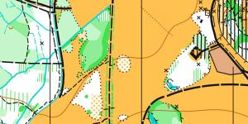
The event is being run in conjunction with a SOS colour-coded event and there will be an opportunity for adults to do a course but please note that no accompanying adults (teachers, assistants or parents) will be permitted in the competition area while championship competitors are running

Further information will be on the SOS website at www.stragglers.info or email Julie.Laver@virgin.net

